Project 4 Task 1 – Yelp Search App

Example, by Shubham Jaiswal

Description:

My application takes a search string from the user, and uses it to fetch and display a

Restaurant name, image, contact and URL of the restaurant from Yelp.

Here is how my application meets the task requirements

1. Implement a native Android application

The name of my native Android application project in Android Studio is:

YelpSearchAndroidApp

1.1. Has at least two different kinds of views in your Layout (TextView, EditText,

ImageView, etc.)

My application uses 4 TextView, EditText, Button, and ImageView. See

content_main.xml for details of how they are incorporated into the LinearLayout.

Edit text to get the input from the user

Text views to show the restaurant name, contact, url, and a generic statement that shows that a restaurant was found

Imageview to show the image of the restaurant as fetched from Yelp

Here is a screenshot of the layout before the picture has been fetched.

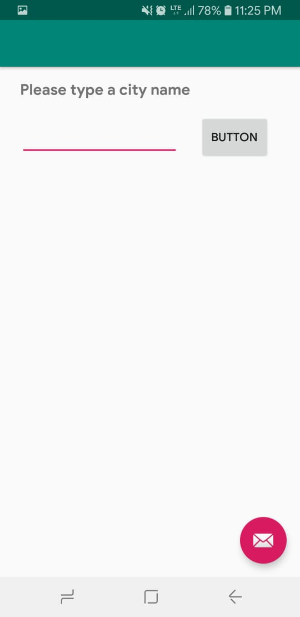

1.2. Requires input from the user

Here is a screenshot of the user searching for a restaurant in Pittsburgh

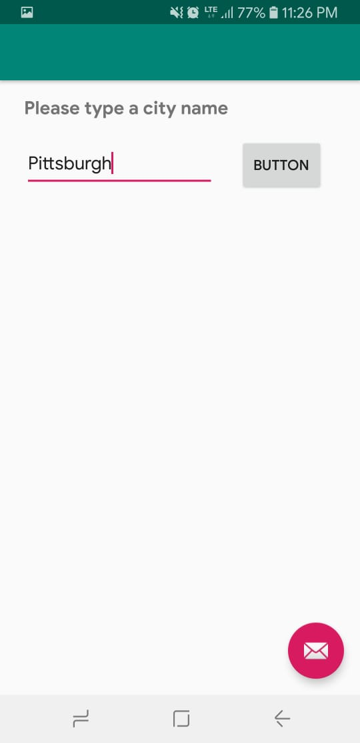

1.3. Makes an HTTP request (using an appropriate HTTP method) to your web

service

My application does an HTTP GET request in GetRestaurant.java. The HTTP request is:

"https://secret-savannah-24775.herokuapp.com/getResults?location="+searchTerm

where search is the user's search term.

The search method makes this request of my web application, gets the data from the web in the form of a json. I return all the data fetched in the Json as a ReturnType object. I have a ReturnType.java class that has variables that are required by the app. Then these are sent over to the app

1.4. Receives and parses an XML or JSON formatted reply from the web service

An example of the JSON reply is:

{"image":"https:\/\/s3-media1.fl.yelpcdn.com\/bphoto\/gKpB-w2eQKdKvTvGzSbk3g\/o.jpg","contact":"(620) 331-4487","name":"Ane Mae's Coffee & Sandwich House","url":"https:\/\/www.yelp.com\/biz\/ane-maes-coffee-and-sandwich-house-independence?adjust_creative=wmdAUwylOUb6qD6Lkeus5g&utm_campaign=yelp_api_v3&utm_medium=api_v3_business_search&utm_source=wmdAUwylOUb6qD6Lkeus5g"}

1.5. Displays new information to the user

Here is the screen shot after the restaurant is fetched from Yelp

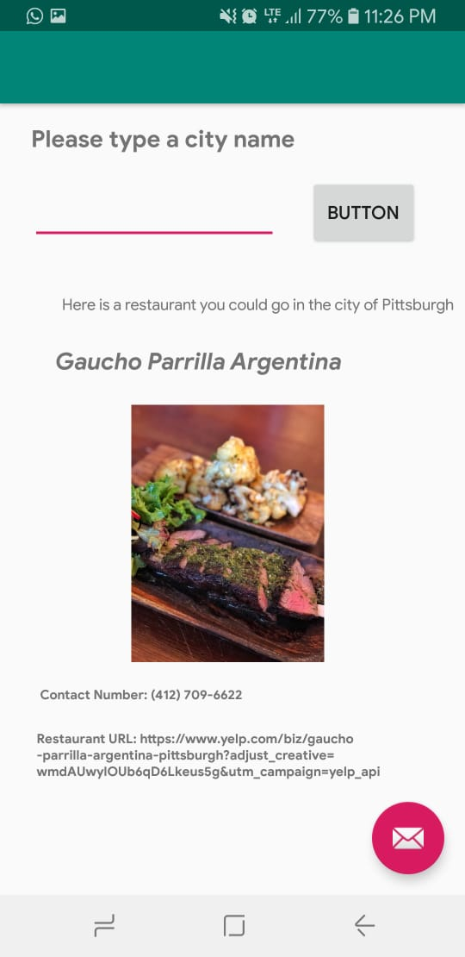

1.6. Is repeatable (I.e. the user can repeatedly reuse the application without

restarting it.)

The user can type in another search term and hit Submit. Here is an example of

having typed in "San Diego".

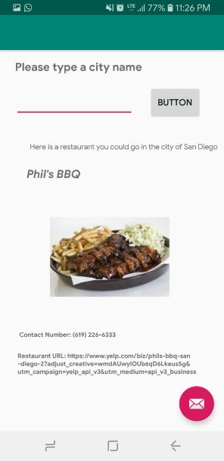

2. Implement a web application, deployed to Heroku

The URL of my web service deployed to Heroku is:

secret-savannah-24775

The project directory name is Project4Task1.

2.1. Using an HttpServlet to implement a simple (can be a single path) API

In my web app project:

Project4Task1Servlet.java gets the searchTag from the app and makes an Http connection to fetch the data from the Yelp api.

The api is : https://api.yelp.com/v3/businesses/search?location="+**searchTag**+"&limit=1

2.2. Receives an HTTP request from the native Android application

Project4Task1Servlet.java receives the HTTP GET request with the

argument "search".

2.3. Executes business logic appropriate to your application

Project4Task1Servlet.java makes an HTTP request to:

https://api.yelp.com/v3/businesses/search?location="+**searchTag**+"&limit=1.

It then parses the JSON response and extracts the parts it needs to respond to the

Android application in the form of a ReturnType object.

2.4. Replies to the Android application with an XML or JSON formatted response.

The servlet sends the data to the app in the form of a ReturnType (a class in the project) object. The App then accesses this data and sets the textView and imageView accordingly